DBMS Practical Lab

Practical 2

Aim: To implement Basic DBMS Queries

1. **To Create a Table**

CREATE TABLE STUDENT(STUDENT_ID INT,STUDENT_FIRSTNAME VARCHAR(255),

STUDENT_LASTNAME VARCHAR(255)

);

1. **Displaying the layout of the Table**

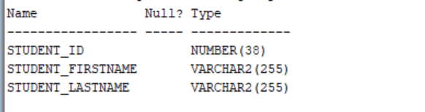DESC STUDENT;

1. **Inserting content in the table**

INSERT INTO STUDENT VALUES(187,'Deivangh','Grover');

INSERT INTO STUDENT VALUES(190,'Aditya','Samal');

INSERT INTO STUDENT VALUES(200,'Himanshu','Vats');

1. **Displaying the content of the table**

SELECT * FROM STUDENT;

1. **Delete a row with condition**

DELETE FROM STUDENT WHERE STUDENT_ID=187;

SELECT * FROM STUDENT;

1. **Truncate the table**

**TRUNCATE TABLE STUDENT ;**

**SELECT * FROM STUDENT;**

1. **Dropping the table**

DROP TABLE STUDENT;

